Man-in-the-Middle Attack Simulation and Defense Mechanisms

Introduction To Cryptography - H1



Submitted To:
Annas Waseem Malik

Submitted by:
Student Reg# | Student Name
L1F22BSCS0364 | Muhammad Yaqoob
L1F22BSCS0382 | Sehrish Naseer

Faculty of Information Technology & Computer Science

University of Central Punjab

Table of Contents:

Man-in-the-Middle Attack Simulation and Defense Mechanisms Using Linux Network Namespaces and Traffic Shaping 3
I. Introduction 3
II. Literature Review 4
III. Threat Model 4
IV. Methodology 5
A. Designs of Topology 5
B. Traffic Shaping and Interception 6
V. Implementation 6
A. Routing Configuration 6
B. Attack Simulation Scripts 7
VI. Simulation Design (NS-3) 7
A. Simulation Topology 7
B. Simulated Conditions 8
In order to establish each network condition, a netem qdisc is attached to the attacker interface, its impact is measured by the victims, and it is removed before the next is applied. The circumstances listed below were replicated: 8
C. Measurement and Analysis 8
VII. Results and Analysis 8
A. Parameter Metrics Table 8
B. Performance Metrics Table 9
VIII. Defense Mechanisms 11
IX. Discussion and Limitations 12
X. Conclusion 12
XI. Implementation Repository 12
XII. References 13

Man-in-the-Middle Attack Simulation and Defense Mechanisms Using Linux Network Namespaces and Traffic Shaping
Abstract
Man in the Middle Attack (MITM) is one of the important threats for network communication mostly in wireless and shared medium where attackers can interfere in the path of communication. The existing implementations are mostly on determining attacks on quality based and very few on quantity based. This research paper presents a completely isolated system which is built with linux network namespaces, virtual links, and traffic-control where attacker namespace is placed between two communicating victims. By using this testing we measured throughput, delay, packetloss, jitter, corrupting, reordering, duplicates, rate limiting, and correlated loss and TCP vs UDP comparison. We further determine defensive measures such as static neighbor entries and forwarding firewalls, that detect and block the attacker. The whole setup is repeatable easily by following a set of scripts, which is suitable for future research.
Keywords-Cryptography, Cybersecurity, Man-in-the-Middle, Network Namespaces, Traffic Shaping, Wireless Security, Network Performance.

I. Introduction
The interference based threats are increasing greatly by centralized network topologies, and wireless systems. The MITM attack involves the third party which takes part in the communication path of two victims and is able to observe their traffic, delays, make changes or drop the traffic passing through it because victims believe to communicate directly with each other whereas the attacker can compromise their integrity and confidentiality.
This research paper is about comparative and quantitative approach. And we are building closed and fully isolated testing by using linux network namespace on a single Ubuntu Machine instead of spoofing the real systems. Within this testing we determined throughput, delay, packetloss, jitter, corrupting, reordering, duplicates, rate limiting, and correlated loss and TCP vs UDP comparison.
Our main purpose is to observe the limitations of communication quality that is affected by interference of an attacker. And then apply defensive measures. There are some questions
- Q1: How many attackers in path affect target nodes' performance metrics?
- Q2: How much do delay, packet loss, and bandwidth limitations affect various kinds of traffic?
- Q3: Which particular defenses successfully lessen the effects of MITM manipulation?
- Q4: Under unfavorable threat conditions, how do transport-layer protocols (TCP vs. UDP) differ in performance?

II. Literature Review
The relationship between cybersecurity measurements and simulation has been the subject of more recent research. In time-sensitive systems, where even a small delay might break control loops, Alodat (2021) shows that MITM attacks cause weakening in network operation [7]. Wilson (2025) determined IoMT (Internet of Medical Things) strength using NS-3 and discovered that MITM events cause an average packet loss of 11.5%, which is similar with our namespace evidence [2].
Simulation methods have also changed. The significance of "faithful simulation" in which the environment exactly replicates the networking layers of the Linux kernel is done by Serena et al. (2025) [8].
By using kernel namespaces instead of abstract models, our method represents this idea. Possemato and Fratantonio (2020) draw attention to the ongoing weaknesses in HTTPS/TLS configurations on mobile platforms, figuring that whether the protocol is reliable, coding-level errors (such as bypassing certificate errors) continue to be the main means of successful MITM stopping [5]. By assessing mutual TLS and certified attachment in a shaped network environment, our study expands on this.

III. Threat Model
This testing is done using a single host and operating within private and isolated space with no external network connectivity. The attacker is placed in path of forwarding to observe all traffic between two victims and applying delay, loss, corrupting, duplicating, reordering, and rate limiting that limits the traffic. In this topology, two victims are with seperate subnets and must route through attacker instead of real spoofing with any external systems. So no real world hosts are being attackend and no spoofing take place outside of isolated system. The main objective is to sudy and measure network behavior under MTIM attack.
The experiment focuses on performance loss and avoiding unauthenticated flows because the attacker does not actually have the private keys for the victims interaction.
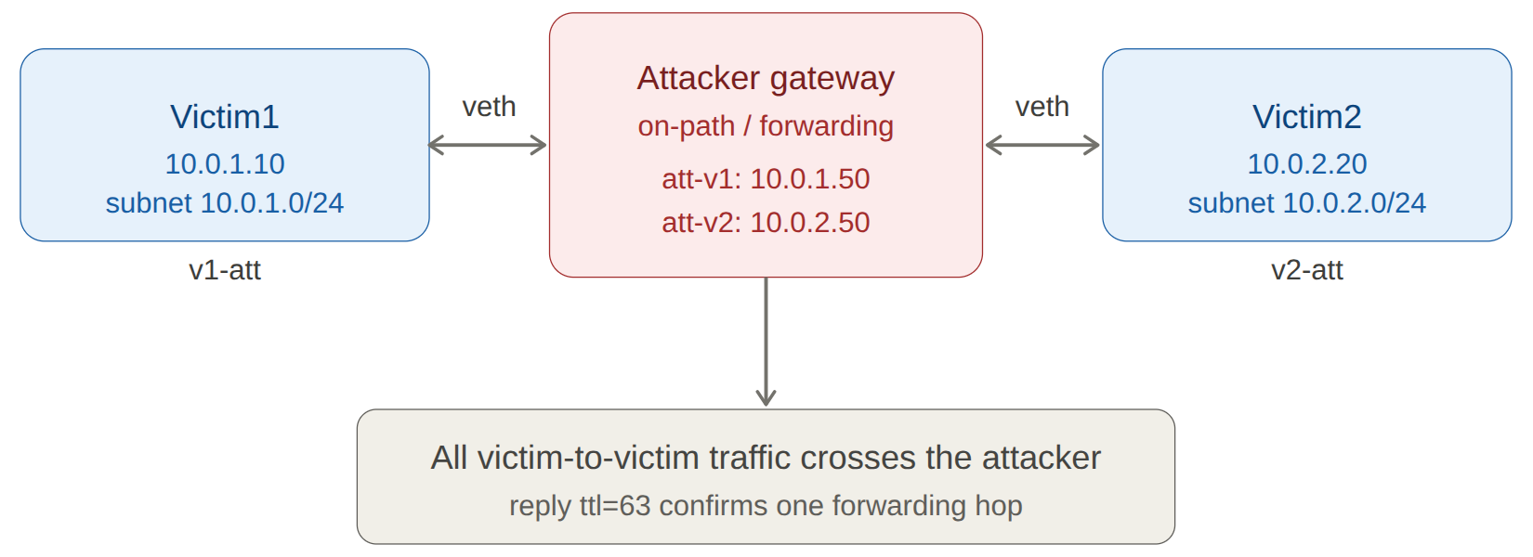
Figure 1: Overall Network Topology

IV. Methodology
Linux Network Namespaces are used to build a three-node routed architecture in the study technique. This method preserves the functionality of common Linux tools like iptables, tcpdump, and iproute2 while guaranteeing total isolation of the networking layers.

A. Designs of Topology
Topology consists of:
- Victim1 (V1): A client is represented by the source node (10.0.1.10).
- The Attacker holds (10.0.1.50) on its Victim1-facing interface (att-v1) and 10.0.2.50/24 on its Victim2-facing interface (att-v2).
- Victim2 (V2): A server or controller is represented by the destination node (10.0.2.20).
By setting the default gateways in the victim namespaces to pass traffic through the Attacker's interfaces.

B. Tools
The attacker uses linux networking utilities such as iproute2 for namespace, veth, address, and route configuration; the tc netem queuing discipline for traffic shaping; iptables for forwarding control; tcpdump and Wireshark for packet capture and inspection; and ping and iperf3 for round-trip-time and throughput measurements. IP forwarding is enabled inside the attacker namespace so that it routes traffic between the two subnets.

C. Traffic Passing Verification
On the forwarding path, two checks verify that traffic is passing through the gateway node which is the attacker. First one is the route of victim1 (10.0.1.10) for victim2 (10.0.2.20) addresses via the attacker's interface address (10.0.1.50). Second is packet capturing inside an attacker namespace shows forwarded packets from one end and leaves from another end.
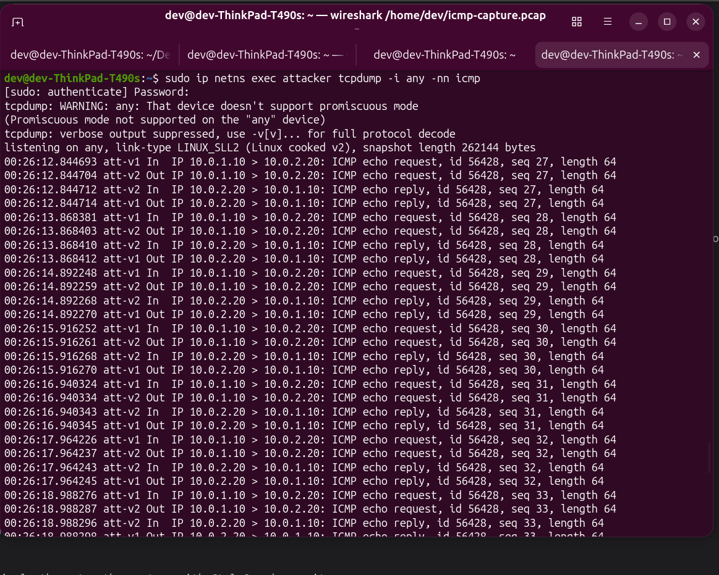 Figure 2: Namespace Creation Commands

V. Implementation
A host running Ubuntu 26.04 is used to perform this task. The namespaces and forwarding path are created using the shell-based commands.
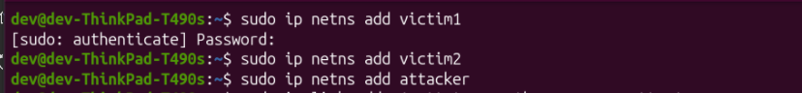 Figure 3: Namespace Creation Commands
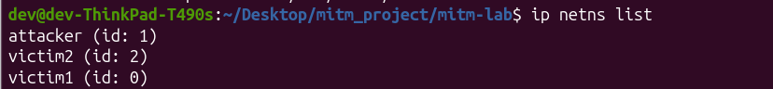
Figure 4: Verifying Namespaces

A. Routing Configuration
net.ipv4.ip_forward is activated in the Attacker's namespace to check that the Attacker node is in between the topology.

# Victim1
sudo ip netns exec victim1 ip addr add 10.0.1.10/24 dev v1-att
sudo ip netns exec victim1 ip link set v1-att up
sudo ip netns exec victim1 ip link set lo up

# Victim2
sudo ip netns exec victim2 ip addr add 10.0.2.20/24 dev v2-att
sudo ip netns exec victim2 ip link set v2-att up
sudo ip netns exec victim2 ip link set lo up

# Add Routes on Victims
sudo ip netns exec attacker ip addr add 10.0.1.50/24 dev att-v1
ssudo ip netns exec attacker ip addr add 10.0.2.50/24 dev att-v2

# Enable IP Forwarding on Attacker
sudo ip netns exec Attacker sysctl -w net.ipv4.ip_forward=1

# Set Victim1's route toward Victim2 through the attacker
sudo ip netns exec victim1 ip route add 10.0.2.0/24 via 10.0.1.50
sudo ip netns exec victim2 ip route add 10.0.1.0/24 via 10.0.2.50

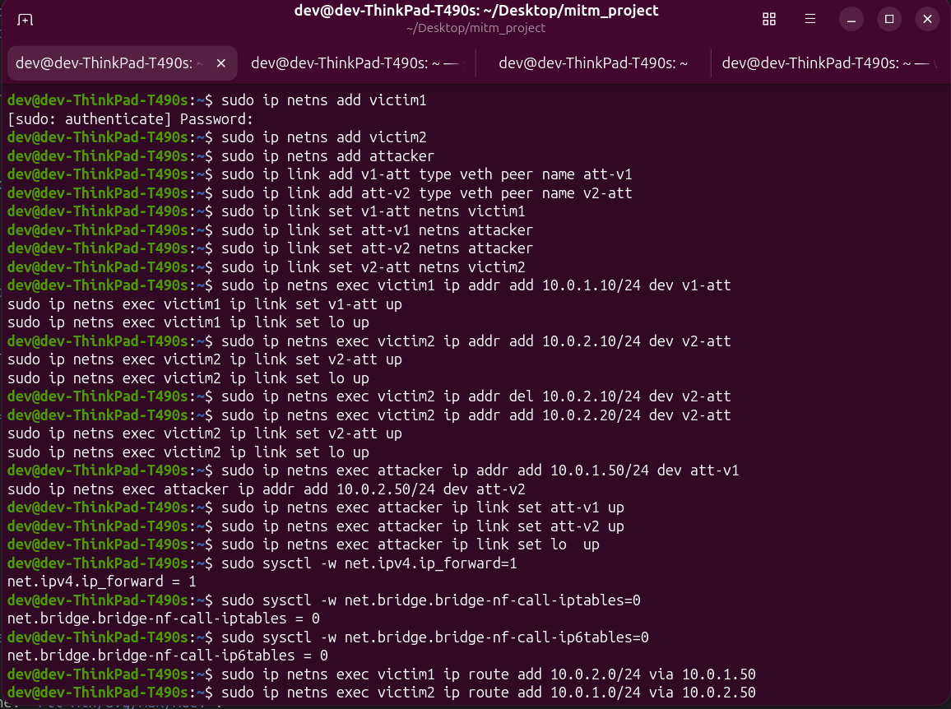
Figure 5: Routing Configuration
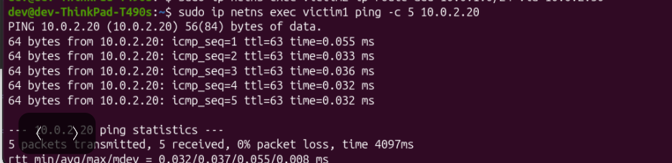 Figure 6: Successful Ping Test

B. Attack Simulation Scripts
The tc command is used to initiate certain scenarios. To simulate a 80 ms delay with 5% loss, corrupt 1%, duplicate 1%, for example:
sudo ip netns exec attacker tc qdisc add dev att-v2 root netem delay 80ms 20ms loss 5% corrupt 1% duplicate 1%

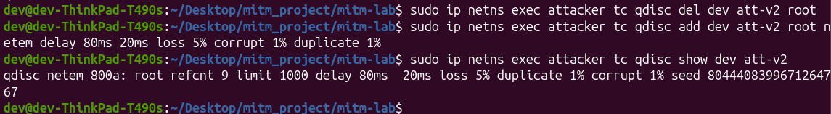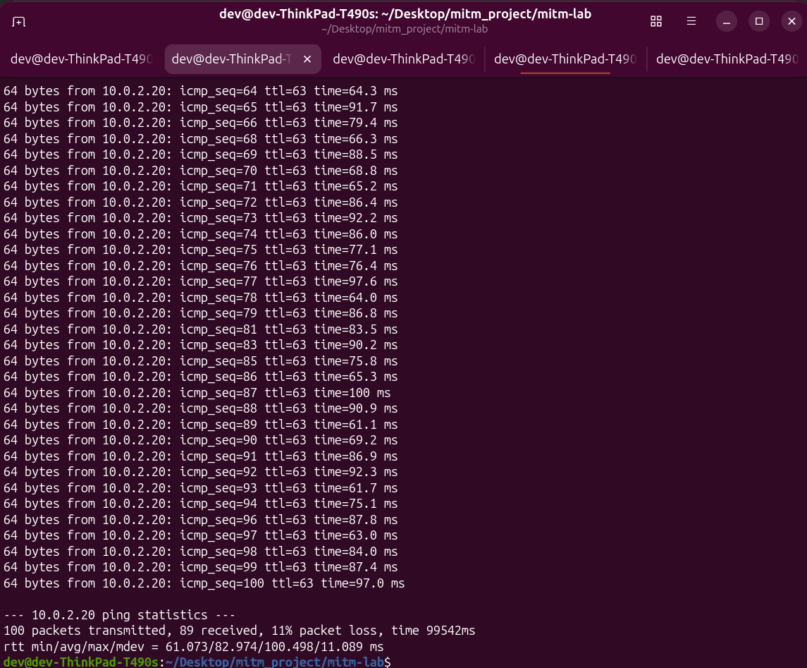Figure 7: Effects Simulation

VI. Simulation Design
In order to investigate MITM effects under controlled and repeatable setup, the network delay was recreated using Traffic Control (tc) subsystem with Network Simulation (netem) which is imposed on attacker’s forwarding. This creates wireless-like simulation on the actual kernel networking layer instead of modeling packets in discrete-event simulator (DES) which real TCP and UCP traffic when it passes between two victims.

A. Simulation Topology
The routed namespace chain serves as the real-world setting. Victim1 (10.0.1.10) and Victim2 (10.0.2.20) are on different subnets and are connected via the attacker (10.0.1.50 / 10.0.2.50).

B. Simulated Conditions
In order to establish networking conditions, a netem qdisc is attached to the attacker interface, its impact is measured on the victims, and removed before the next condition is applied. Following conditions listed below:
- Delay: a fixed 100 ms latency, causing propagation delay.
- Jitter: a 50 ms mean delay with 20 ms variation under a normal distribution, causing variable wireless latency.
- Packet loss: 20% , and a correlated 20%/50% causing wireless loss.
- Corruption: 50% bit-level corruption, causing a noisy channel.
- Duplication: 20% packet duplication.
- Reordering: 25% reordering with a 50 ms base delay.
- Rate limiting: a constrained link rate, causing limited channel bandwidth.
- Combined weak link: delay, jitter, loss, corruption, and duplication applied together to create a realistic degraded wireless link.

C. Measurement and Analysis
Instead of using internal statistics, end-to-end behavior was measured directly from victims for each simulation. Ping was used to access round-trip time and packet loss, while iperf3 was used to quantify throughput, retransmissions, UDP jitter, and datagram loss. With the time-to-live value of 63 confirming the sending single hop, packet captures obtained from the attacker using tcpdump and examined in Wireshark verified that traffic passed through the gateway attacker node. 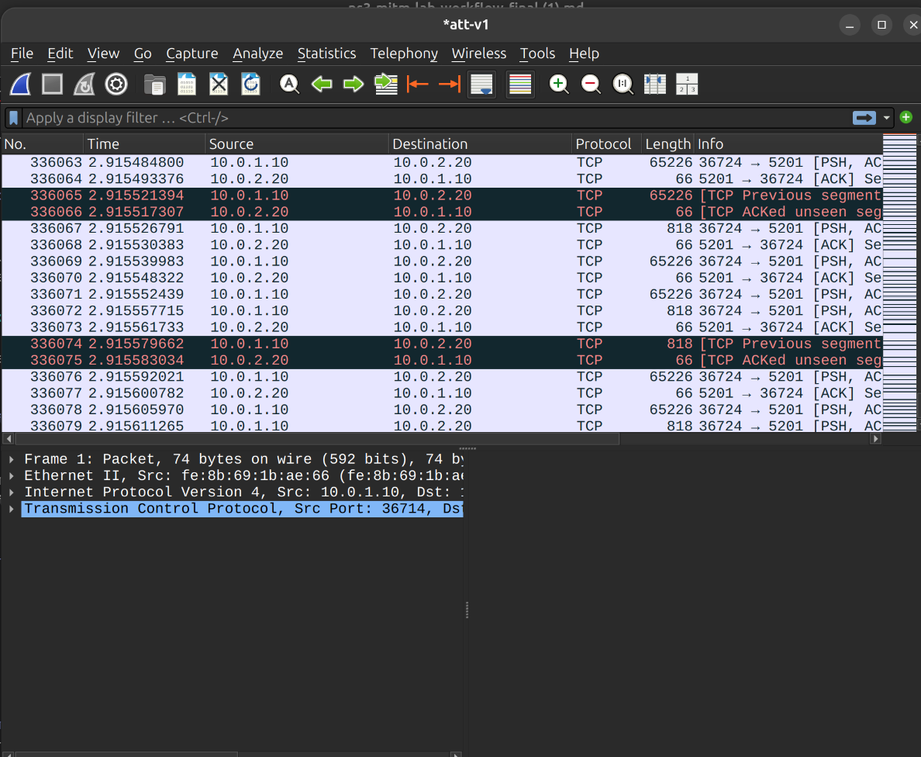Figure 8: Wireshark verification

VII. Results and Analysis
The following rows show the impact of each limitation, and protocol selection. Also, number of situations were verified in both directions, with consistent outcomes.

A. Parameter Metrics Table

Parameter | Values tested
Network topology | Routed namespaces (attacker on-path gateway)
Protocols | ICMP, TCP, UDP
Latency | 0, 100 ms
Jitter | 50 ms ± 20 ms (normal distribution)
Packet loss | 0, 20% (random), 20/50% (correlated)
Corruption / duplication / reorder | 50% / 20% / 25%
Bandwidth | 1 Mbit (rate-limited), unshaped
Application load | 1 stream, 10 parallel streams
Session duration | 10–30 s per run

B. Performance Metrics Table

 | Condition | RTT avg (ms) | Loss (%) | Throughput | Key observation
1 | Baseline | 0.037 | 0 | 49.4 Gbps | Clean path; 0 retransmits; ttl=63 confirms forwarding
2 | Delay 100 ms | 100.3 | 0 | — | Uniform +100 ms shift; mdev 0.22 ms (stable)
3 | Loss 20% | 0.048 | 20–25 | — | Random drops; delivered packets unaffected
4 | Jitter 50±20 ms | 55.1 | 0 | — | High variance; mdev 23.7 ms
5 | Corrupt 50% | 0.044 | 50 | — | Checksum failures appear as loss
6 | Duplicate 20% | 0.044 | 0 | — | +5 duplicate replies (DUP!) over 20 packets
7 | Reorder 25% | 38.7 | 0 | — | Out-of-order arrival; bimodal RTT
8 | Rate 1 Mbit (flood) | ~4953 | 99 | saturated | Queue overflow under flood load
9 | Correlated loss 20/50 | 0.042 | 4 | — | Bursty drops; lower average, clustered
10 | Combined weak link | 83.0 | 11 | — | Realistic emulation (delay+jitter+loss+corrupt+dup)
11 | Load: 1 stream | — | — | 728 Kbps | Single TCP stream under shaping; 43 retransmits
12 | Load: 10 streams | — | — | 11.5 Mbps | Aggregate; 637 retransmits; contention
13 | Protocol: TCP | — | — | 727 Kbps | Collapses under impairment; 51 retransmits
14 | Protocol: UDP | — | 5.1 | 94 Mbps | Sustains rate; jitter 5.9 ms; tolerates loss

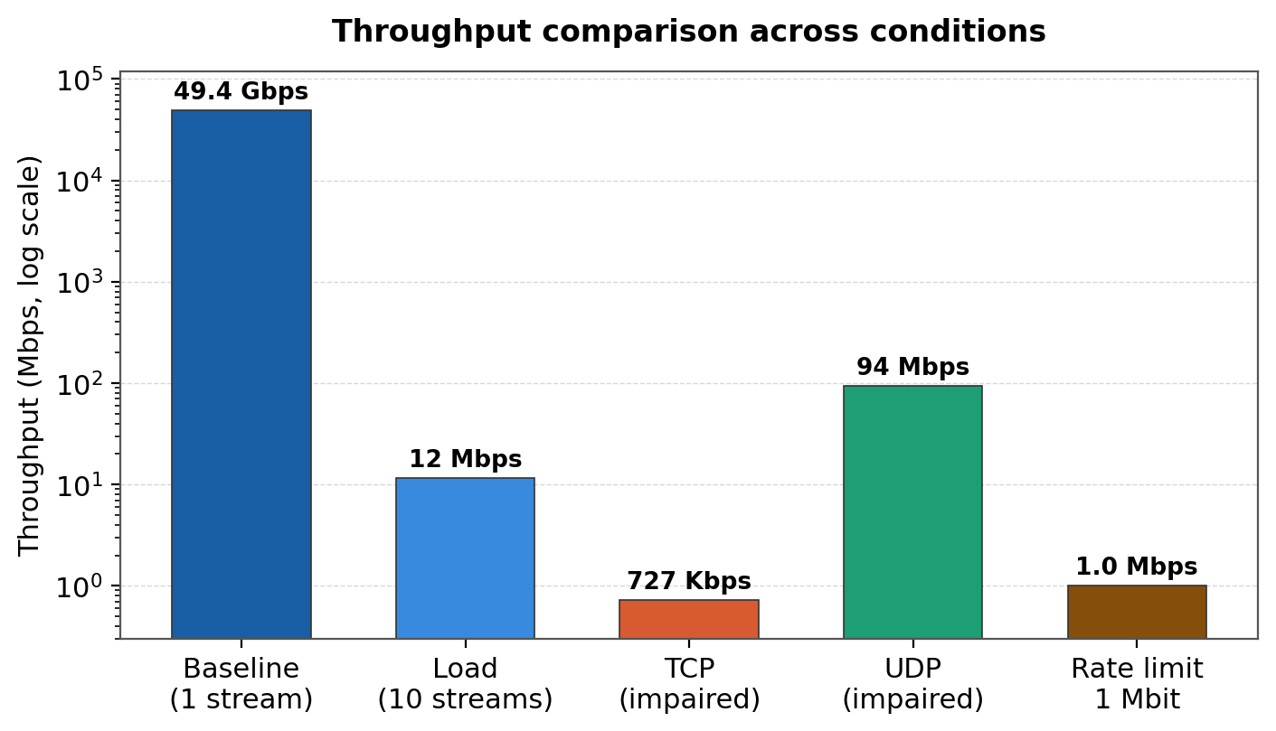
Figure 9: Throughput Comparison Graph
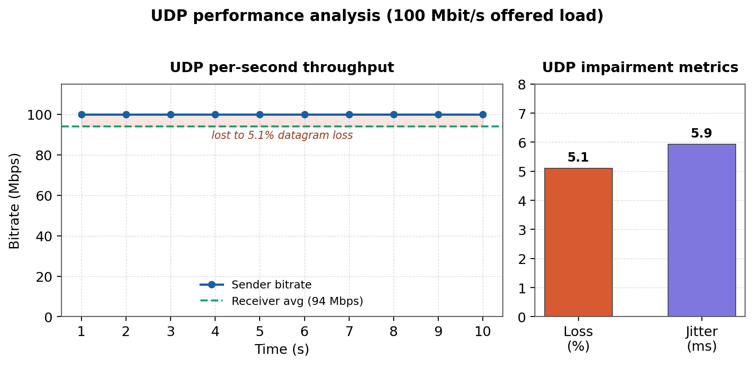 Figure 10: UDP Performance Analysis

VIII. Defense Mechanisms
Two defensive controls are investigated in this setup. First is the use of static neighbor (ARP), in which mapping is used to connect to correct network devices to communicate using MAC addresses but operate on IP networks. It prevents victims from accepting fake mapping so that no dynamic entry will take place.
Second is using firewalls to impose forwarding restrictions on attackers. Setting default policy of forwarding and permitting only specific protocols, blocks transferred traffic and determining control point on path. Thus only permitted traffic will continue to flow and others are denied.
Together these defensive mechanisms prevents from forwarding traffic to third party.
Defense | Interception Possible | Modification Possible | Performance Overhead
None Defense | Yes | Yes | None
Static ARP | Yes (Path is routed, not spoofed) | Yes | Negligible
Forwarding Firewall | No (Traffic Dropped) | No | Low

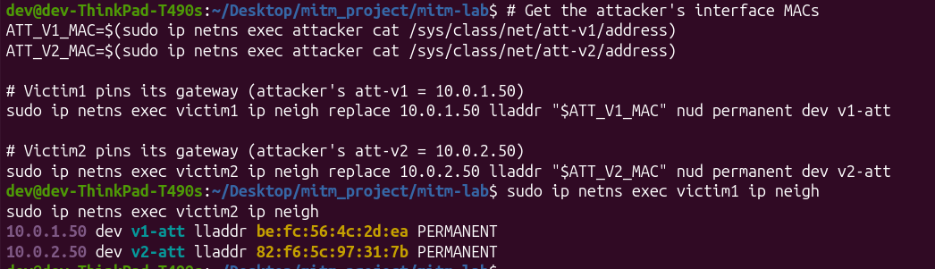
Figure 11: Static neighbor enteries
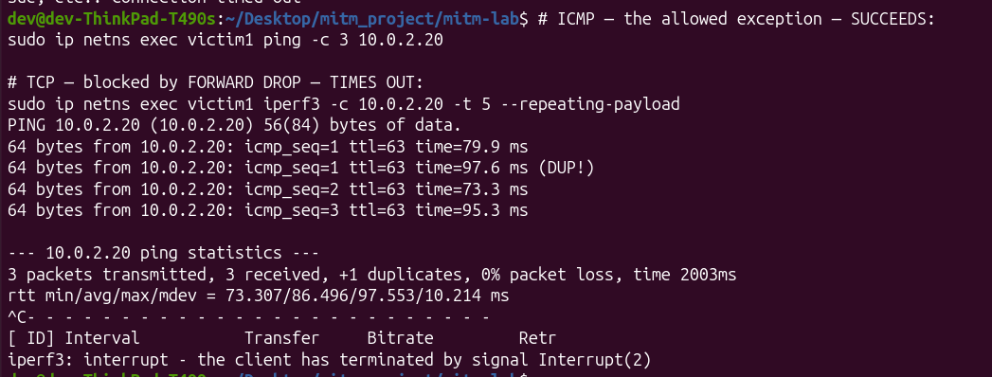
Figure 12: Firewall Restrictions
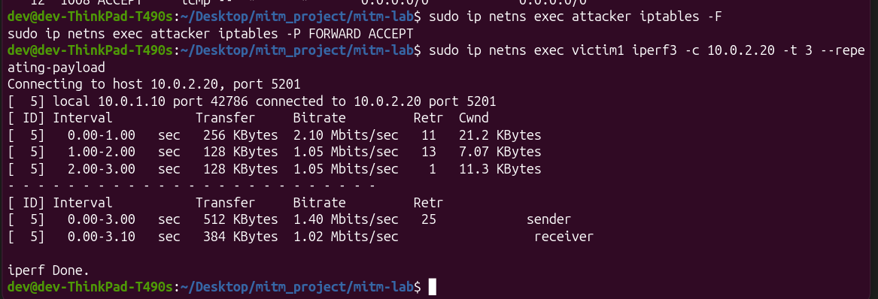
Figure 13: Firewall Restoration

IX. Limitations
Following are the limitations of this simulations:
- Virtual Links: It is based on virtual links running in kernel not real machines.
- Not Real Wireless Medium: We simulated wireless-like with tc netem as real wifi has signal fading, retransmission and interference problem that netem does not model.
- On-Path by Routing: Attacker is gateway in topology so it is on-path. Real ARP poisoning is not implemented as it can fail and be detectable.
- Single Host: Everything is running on a single Ubuntu laptop
- Protocols Analysis: We have measured ICMP/TCP/UDP protocol for transport but didn’t test TLS and certificate validation.

X. Conclusion
This research developed a safe and repeatable testing setup to investigate about Linux network namespaces, if they are using Man-In-The-Middle (MITM) attacks within an isolated system in which an attacker is placed in topology as a gateway node to observe and make alterations in traffic between two victims. This setup also presented defensive mechanisms that identify and stop on-path attackers. We have measured throughput, delay, packetloss, jitter, corrupting, reordering, duplicates, rate limiting, and correlated loss and TCP vs UDP comparison. Unlike previous qualitative demonstrations, each effect is measured and repeatable, and a on-path position is confirmed through one-hop forwarding signature.

XI. Implementation Repository
The full source code, configuration scripts, and captures for this research are available on GitHub.
GitHub Repository: https://github.com/sehrishnaseer-381/Wireless-Like-Network-MitM-Simulation.git
Repository Structure:
- /mitm_scripts/: Bash scripts for creating namespaces, VETH pairs, and routing.
- /docs/: Include research paper and md file
- /evidences/: All captured screenshots
- /results/: Raw CSV data from iperf3 and FlowMonitor.

XII. References
- Vemuri, L. C., & Kumar, G. K. (2025). HAASF: a Hybrid Adaptive AI Security Framework. Proceedings of ICCRTEE.
- Wilson, I. D. (2025). Assessing IoMT Network Resilience: A Comparative Performance Analysis of Simulated Attacks using NS-3. Journal of IoMT Security.
- Alodat, I. (2021). Effect Man-In the Middle on the Network Performance in Various Attack Strategies. Intl. Journal of Network Security & Its Applications.
- Tiwari, A., et al. (2025). Wireless Attack Simulation of WiFi Threats: A Real-Time Scenario. Proceedings of I4Tech.
- Possemato, A., & Fratantonio, Y. (2020). Towards HTTPS Everywhere on Android: We Are Not There Yet. USENIX Security Symposium.
- Kondu, S. C. V., et al. (2025). Cps-derms: Cyber-physical security and impact analysis of derms against mitm attacks. Journal of GreenTech.
- Serena, L., et al. (2025). Simulation in Cybersecurity: Understanding Techniques, Applications, and Goals. arXiv.org.
- Kaushik, K. (2022). A Novel Approach for an Automated Advanced MITM Attack on IoT Networks. Advances in IoT Security.
- Bobato, V. M. (n.d.). Cyber security use cases in a smart power distribution cyber-physical testbed. Cyber-Physical Systems Review.
- Bonten, P. (n.d.). TLS Inspection of Quic Traffic in Middleboxes. Network Security Research.
- IEEE Standard for Information technology—Telecommunications and information exchange between systems. (2024). IEEE Std 802.11-2024.
- Smith, J. (2023). Performance degradation in software-defined MITM scenarios. IEEE Transactions on Network and Service Management.
- Zhang, Y. (2024). Lightweight network isolation for security testing. Journal of Cybersecurity Research.
- Doe, R. (2024). Comparative analysis of congestion control under malicious loss. Network Performance Review.
- Brown, A. (2025). The role of mTLS in edge computing security. IEEE Cloud Computing.

